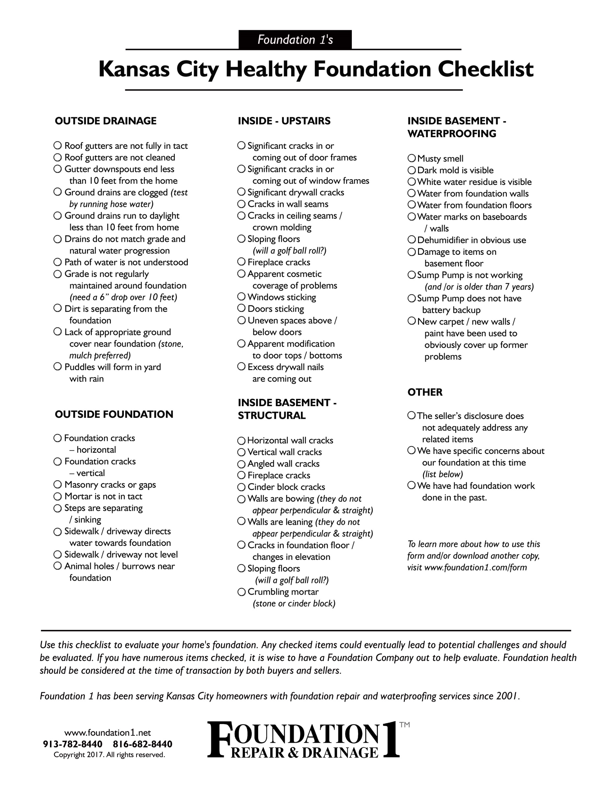

**Randy Vanderpool - Keller Williams Assoc.**

randy@randyvanderpool.com

Phone: 913-825-4026 Mobile: 913-707-2796

Office: 913-906-5400